**Select ….. Group By**

* To collect data across multiple records and group the results by one or more columns.
* Usually used with aggregate functions.

**Syntax**

SELECT expression1, expression2..., expression_n,

Aggregate function (expression)

FROM tables

[WHERE conditions]

GROUP BY expression1, expression2..., expression_n;

**expression1, expression2 ..., expression_n**

The expressions that are not encapsulated within an aggregate function and must be included in the GROUP BY clause.

**Aggregate function**

They basically summarize the results of a particular column of selected data.

* AVG() - Returns the average value
* COUNT() - Returns the number of rows
* FIRST() - Returns the first value
* LAST() - Returns the last value
* MAX() - Returns the largest value
* MIN() - Returns the smallest value
* SUM() - Returns the sum

**Tables**

The tables that you wish to retrieve records from. There must be at least one table listed in the FROM clause.

**WHERE conditions**

Optional. The conditions that must be met for the records to be selected.

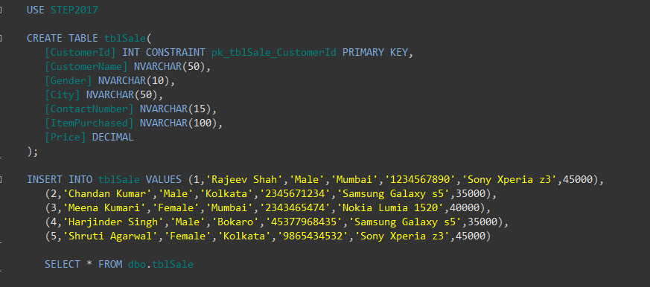

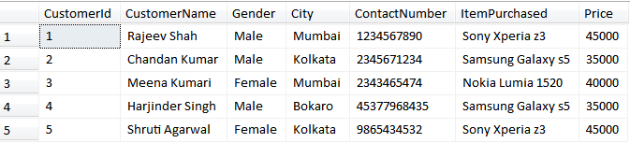

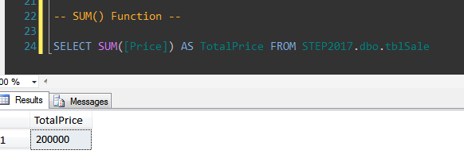

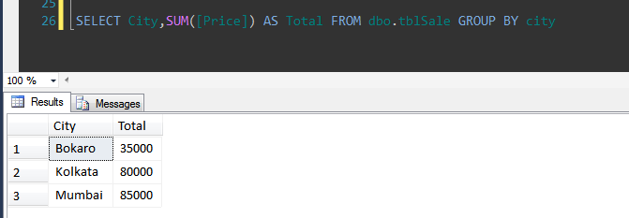

When GROUP BY is not given, it gives the error

Column 'dbo.tblSale.City' is invalid in the select list because it is not contained in either an aggregate function or the GROUP BY clause.

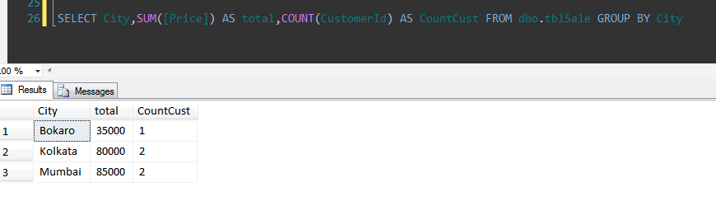



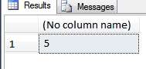

* We want the records based on some condition.
* Where condition can be used.
* For example, we want only the records whose gender is female.
* When we use a having clause, the condition we pass in this clause must be present in the select clause and the group clause or just in the group by clause.

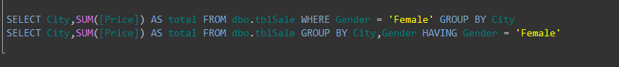

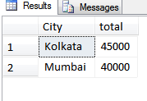

* If giving Gender along with the columns in Select statement but not in GroupBy clause, it shows error.

Column 'dbo.tblSale.Gender' is invalid in the select list because it is not contained in either an aggregate function or the GROUP BY clause.

**Difference between WHERE and HAVING**  
The **WHERE** clause can be used with Select, Insert, Update and Delete statements whereas the **HAVING** clause can be used with the Select statement.  
  
**WHERE** clause filters rows before aggregation whereas **HAVING** filters groups after aggregation.  
  
An aggregate function cannot be used in the WHERE clause unless it is in a sub-query contained in a HAVING clause whereas aggregate functions can be used in a HAVING clause.

MAX () – Selects the maximum value from a table

MIN () – Selects the minimum value from a table

